**Neural Style Transfer of Paintings to Portraits and Selfies**

**Group 7**

**Team Members:** Ömer Ünlüsoy (21702136), Ata Berk Çakır (21703127), Doğa Tansel (21802917), Mustafa Hakan Kara (21703317), Ahmet Cemal Alıcıoğlu (21801700)

**Question Description**

In this project, we plan to create a convolutional neural network that blends the style of an image with the contents of another image. This image stylization technique is called Neural Style Transfer (NST). With this technique, users can easily create artistic images out of regular photographs. Our focus will particularly be on human portraits and selfies. We aim to transfer the style of paintings to these types of images. Several examples of such style transfers are shown in the Figure 1.

In addition, we will also try to allow users to re-style their selfies by only specifying a certain art movement, such as Fauvism, Impressionism, Expressionism, etc. In other words, users will not need to provide an image whose style will be transferred.

**Datasets**

We plan to use two different types of datasets that will consist of human portraits/selfies and paintings with different styles.

Selfiecity, CRCV Selfie, Matting Human, and Selfie Image Detection datasets will be used for human portraits/selfies [1, 2, 3, 4]. In addition, Van Gogh Paintings, Best Artworks of All Time, Portrait Paintings, and Paintings datasets will provide us with many well-known paintings to train or fine-tune our model [5, 6, 7, 8].

**Planned Milestones**

We currently plan to choose PyTorch as the machine learning framework. We can make use of Transfer Learning with pre-trained models. The VGG-19 model can be used since it has enough complexity for this task. Thus, the need for a large dataset can significantly decrease. The initial plan is that we will learn the basics of CNN implementation with PyTorch and how to implement a pre-trained model to our CNN. Style Transfer can be done using mainly feature extraction from standard CNNs. Thus, we will learn how feature extraction can be applied to a CNN model and how to manipulate these features to obtain a blended final image. In case our GPUs are not sufficient for the training process, we can benefit from CoLab or Google Cloud Services.

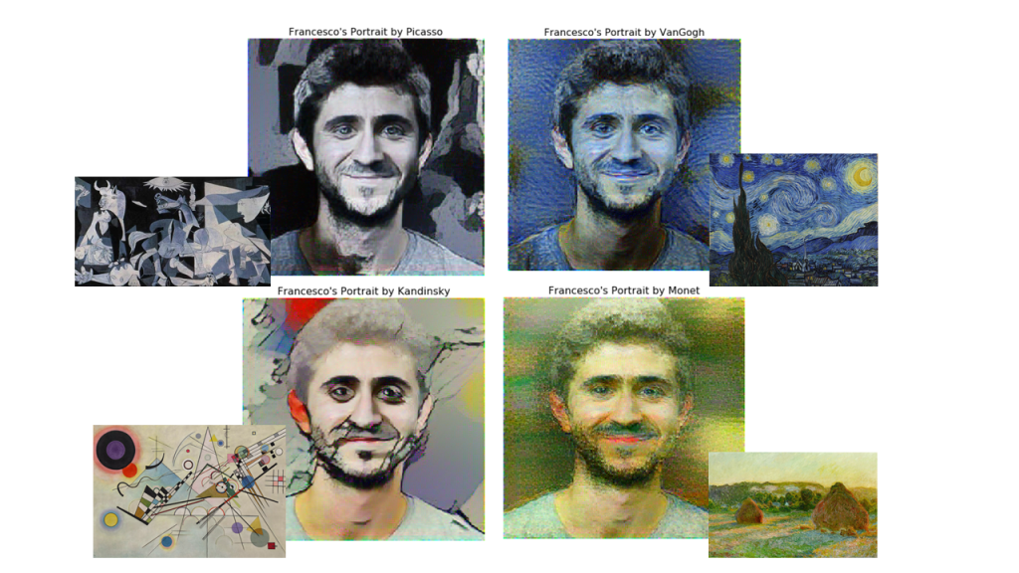

Figure : Style Transfer of Four Different Paintings to a Portrait

**References**

[1] “Selfiecity” <http://selfiecity.net/#imageplots>.

[2] “CRCV Selfie” [https://www.crcv.ucf.edu/data/Selfie.](https://www.crcv.ucf.edu/data/Selfie/)

[3] “Matting Human” <https://www.kaggle.com/laurentmih/aisegmentcom-matting-human-datasets>.

[4] “Selfie Image Detection” https://www.kaggle.com/jigrubhatt/selfieimagedetectiondataset.

[5] “Van Gogh Paintings” <https://www.kaggle.com/ipythonx/van-gogh-paintings>.

[6] “Best Artworks of All Time” <https://www.kaggle.com/ikarus777/best-artworks-of-all-time>.

[7] “Portrait Paintings” <https://www.kaggle.com/deewakarchakraborty/portrait-paintings>.

[8] “Paintings” <https://www.kaggle.com/miroslavsabo/paintings>